Exercise 1: **ANYTHING ELSE**

The hypotheses:

Adding trust-inducing copy on the email, phone and opt-in fields at checkout will lead to an increase in transactions.

Test run dates: 10/18/19- 10/31/19

Device : Desktop, Mobile

The main intention of the test is to observe if there is an increase in engagement and loyalty among the buyers. This can in-turn result in increased customer retention which means steady flow of revenue. And it also cuts down on the costs to constantly acquire new customers.

Once the loyal customers and their buying behavior are identified, we can target specific promotions to retain them. Thus, we can reduce customer churn and manage risk.

If I characterize the distribution of New Users (Fig. 1) , Returning Users (Fig. 2) as below, the plot indicates that there are more New Users and comparatively less Returning Users. This is with the assumption that the New and Returning Users are different since the date range of test period is very small and we are considering only 2 device types. So, there is a potential challenge of maintaining User retention. Access to the account is global and one possible way to address is by re-defining strategic directions to withstand competitive challenges regionally.

In the overall analysis, we see a multi-Channel approach and an increased number of engaged users, pageviews and the number of Users being statistically significant in all the Goals set up on the target page/URL testsite.com/checkout . However, the Revenue has a drastic drop in the test period. A possible cause may be the Pricing factor. When the market is rapidly evolving, to stay competitive, it’s important to regularly review and adjust pricing strategies and differentiating sales order. Another factor could be the high bounce rates which could have offset many users on the Display Channel which had significant Pageviews [Ref:Doc- Exercise 1 - Top 5 Channel, Fig. 3]. The Behaviour analysis of the data also provided insights on how different User groups have interacted with the various Product types. This can help brands engage Users and drive customers to each next stage of sales process.

Figure 1

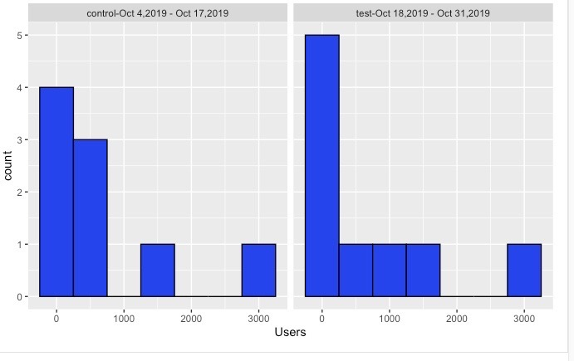

Figure 2